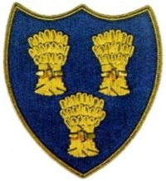
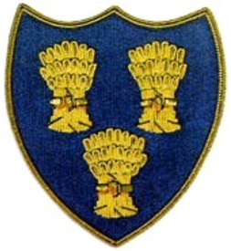
Cheshire Golf U14s
ROYAL LIVERPOOL GOLF CLUB
SUNDAY 12TH APRIL 2026
FIRST TEE -1400

 | ROYAL LIVERPOOL GC |  |  |  |  | CHESHIRE GOLF U14s
Time | Player | HI | CH | strokes | result | Player | HI | CH | strokes | result
1400 | Eamon Palmer | 3.2 |  |  | 3/1 | Aidan Lam-Prestbury | 3.2
 | Olly Edgell | 5.5 |  |  | 3/2 | Jeremy Ju-Hazel Grove | 3.9
 | Connor Wilson | 7.9 |  |  | 3/2 | James Prest-Romiley | 4.7
 | Harvey Eastwood | 9.2 |  |  | 5/4 | Alfie Dunbar-Heswall | 5.7
 | Zach Beesley | 25.9 |  |  |  | T. Balakrishnan-Wallasey | 6.0 |  |  | 6/4
 | Xavier Gardiner | 28 |  |  |  | Henry Quinn-Disley | 7.4 |  |  | 6/5
 | Cruz Norton-Northenden | 9 |  |  |  | Charlie Thompson-Styal | 7.8 |  |  | 4/2
 |  |  |  |  | 4 |  |  |  |  | 3

