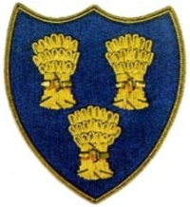
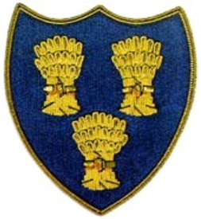
Cheshire Golf U14s
COURSE:-LYMM GOLF CLUB
DATE:- SATURDAY 9TH MAY 26
FIRST TEE -1310

 | LYMM JNR’s |  |  |  |  | CHESHIRE GOLF U14s
Time | Player | HI | CH | strokes | result | Player | HI | CH | strokes | result
1310 | Finlay Read | 7.1 | 7 | 3 | 4/3 | Alfie Dunbar, Heswall | 4.5 | 4
1316 | Elliot Dex | 9.5 | 10 | 2 |  | James Harrison, Astbury | 7.5 | 8 |  | 4/3
1322 | Haydn Wood | 9.7 | 10 | 2 |  | Henry Quinn, Disley | 7.8 | 8 |  | 1Up
1328 | Oliver Dulson | 12.4 | 13 | 4 | 5/3 | Daniel Keegan, Wallasey | 8.9 | 9
1334 | Harry Dulson | 12.6 | 14 | 4 | 1Up | Cruz Norton, Northenden | 9.6 | 10
1340 | Sam Berry | 14 | 15 | 4 | 7/6 | Finley Baker, Helsby | 10.3 | 11
1346 | Michael Clarke | 15.2 | 17 | 6 | 9Up | Luke Doran, Sandiway | 10.7 | 11
1352 | George Clarke | 16.1 | 18 | 6 | 5/4 | Euan Courtney, Hazel Grove | 11 | 12
1358 | Nathan Paul | 22.2 | 25 | 5 | 5/4 | Phoebe Henderson Wmslow | 14.9 | 20
1404 | Daniel Clarke | 29 |  |  |  | Buster Airey, Heswall | 14.8 | 16 |  | 3/2
 |  |  |  |  | 7 |  |  |  |  | 3

