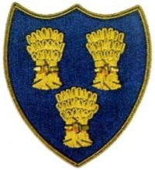
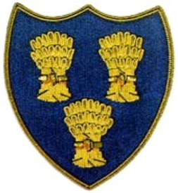
Cheshire Golf U14s
HESWALL GOLF CLUB
SUNDAY 26TH APRIL 2026
FIRST TEE -1330

 | HESWALL JUNIORS |  |  |  |  | CHESHIRE GOLF U14s
Time | Player | HI | CH | strokes | result | Player | HI | CH | strokes | result
 | Alfie Dunbar | 5 | 4 | 3 | 3/2 | Alfie Ogden, Wallasey | 2.1 | 1
 | Sonny Eyes | 10.4 | 11 | 6 | 9/8 | T Balakrishnan, Wallasey | 5.7 | 5
 | Buster Airey | 15.1 | 17 | 7 | 2/1 | Alex Le, Ringway | 9.3 | 10
 | Ewan Delisle | 19.4 | 22 | 11 |  | Finley Baker, Helsby | 10.3 | 11 |  | 3Up
 | Seve Keogh | 20.6 | 23 | 11 |  | Luke Doran, Sandiway | 11.6 | 12 |  | 6Up
 | James Welton | 23.8 | 27 | 4 | 6/5 | Phoebe Henderson, Wilmslow | 18.5 | 23
 | Eu Courtney, H/grove | 11.2 | 12 |  | 3Up | Ed Graham, Wallasey | 12 | 13 | 1
 | Esme Graham, W,Sey | 0.5 | 1 |  |  | Ryan Young, Styal | 11.6 | 12 | 11 | 8/7
 |  |  |  |  | 5 |  |  |  |  | 3

