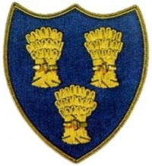
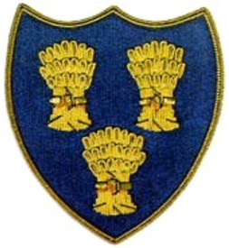
Cheshire Golf U14s
COURSE:-EATON GOLF CLUB
DATE:- SUN 17 MAY 26
FIRST TEE -MIDDAY

 | SHROPSHIRE & HEREFORD U16s |  |  |  |  | CHESHIRE GOLF U14s
Time | Player | HI | CH | strokes | result | Player | HI | CH | strokes | result
1200 | Brodie Miller-Telford | -0.2 | 0 |  | 6/4 | Ricky Mohun-Delamere Fore | 0.6 | 1 | 1
1207 | Ben Steventon-Telford | 0.1 | 1 |  | 6/5 | James Prest-Stockport | 2.8 | 4 | 3
1214 | Harry Slater-Wrekin | 0.4 | 1 |  | 2Up | Jeremy Ju-Hazrl Grove | 3.2 | 4 | 3
1221 | Louie Carroll-Wrekin | 1.1 | 2 |  |  | Alfie Dunbar-Heswall | 4.4 | 6 | 4 | 4/3
1228 | Harry Timmis-Shifnal | 6.3 | 8 | 0 |  | Charlie Thompson-Styal | 6.2 | 8 | 0 | 1Up
1235 | Aliyah Summers-Bridgnorth | 4.4 | 6 |  |  | James Harrison-Astbury | 7.5 | 9 | 3 | 5/3
1242 | *Cruz Norton-Northenden | 9.4 | 12 | 3 | 2/1 | Finley Read-Lymm | 7.1 | 9
1249 | *Casper Bernstein-Ringway | 12.2 | 15 | 5 |  | Henry Quinn-Disley | 7.8 | 10 |  | 4/3
1256 | Zach Summers-Bridgnorth | 15.9 | 19 | 9 | 1 Up | Cormac Narey-Crewe | 8.1 | 10
 | *Cheshire Guests
 |  |  |  |  | 5 |  |  |  |  | 4

