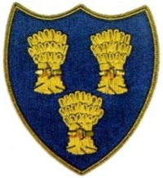
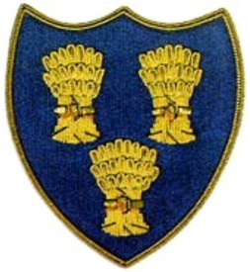
Cheshire Golf U14s
COURSE:-ASTBURY GOLF CLUB
DATE:- SAT 2ND MAY 26

 | Astbury & Alsager |  |  |  |  | Cheshire Golf U14s
Time | Player | HI | CH | strokes | result | Player | HI | CH | strokes | result
1230 | James Woby/Als | 2.2 | 2 |  |  | Jeremy Ju, Hazel Grove | 3.7 | 4 | 2 | 3/2
1236 | Ted Myatt/Als | 5.7 | 6 |  | 4/3 | Henry Quinn, Disley | 7.8 | 8 | 2
1242 | Adam Van Vuuren/Ast | 7.5 | 8 |  |  | Cormac Narey, Crewe | 8.6 | 9 | 1 | 5/4
1248 | James Harrison/Ast | 7.5 | 8 |  | 2/1 | Alex Le, Ringway | 8.7 | 9 | 1
1256 | Luke Ratcliffe/Ast | 11.3 | 12 | 2 | A/S | Cruz Norton, Northenden | 9.6 | 10 |  | A/S
1302 | Corey Fahy/Als | 13.6 | 15 | 5 | 1UP | J Yarwood, Sandiway | 9.6 | 10
1308 | Jack Potter/Als | 14.6 | 16 | 5 | 3/2 | Harry Grey. Wallasey | 9.8 | 11
1316 | Sam Fisher/Ast | 16.9 | 19 | 7 |  | Euan Courtney, Hazel Grove | 11.2 | 12 |  | 1UP
1322 | Max Porter/Ast | 18.3 | 20 | 7 | 2/1 | Ryan Young, Styal | 13 | 13
1328 | Jimmy Brennan/Als | 20.6 | 23 | 7 |  | Buster Airey, Heswall | 14.8 | 16 |  | 6/5
 |  |  |  |  | 5.5 |  |  |  |  | 4.5

